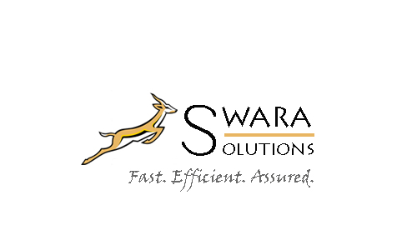

**NAME OF THE TEAM :** SWARA SOLUTIONS**.**

**NAME OF THE CASE STUDY :** MAGARI ERP IMPLEMENTATION PROJECT.

**PROBLEM DEFINITION.**

MAGARI Corporation is a company based in the East African Region with its headquarters in Nairobi. The company imports vehicles and vehicle parts and sells them across the East African Region.

There is a manufacturing unit and vehicle assembly parts at the headquarters in Nairobi.

The Showrooms and Sales Offices are within the following towns in the various countries.

* **Kenya**

Nairobi, Mombasa , Nakuru, Eldoret , Kisumu.

* **Uganda**

Kampala, Jinja

* **Tanzania**

Arusha, Moshi, Dar-es-Salaam

* **Ethiopia**

Addis Ababa

* **South Sudan**

Juba

* **Rwanda**

Kigali

Due to rapid growth, MAGARI has acquired MOTOKAA Holdings that is within Uganda, Rwanda, Ethiopia and South Sudan.

Before acquisition, MAGARI only specialized in FORD, MAZDA and LANDROVER brands.

MOTOKAA brought an additional models in LEYLAND, SKODA and SUZUKI.

There is need to integrate the systems and processes from both MAGARI Corporation and MOTOKAA Holdings.

There should be smooth transition of operations in the various units i.e. Manufacturing and Assembly, Sales, Finance and Procurement.

The Board has set aside a budget that will enable this transformation.

The budget is intended to enable the replacement of the current systems with a flexible ERP.

The ERP should:

* Be flexible.
* Be able to manage the integrated general ledger of the new operation.
* Offer Consolidated financial reporting standard.
* Be able to roll up financial results at group level.

The ERP implementation should be within the laws of the respective territories.

The project should be completed within 12 months.

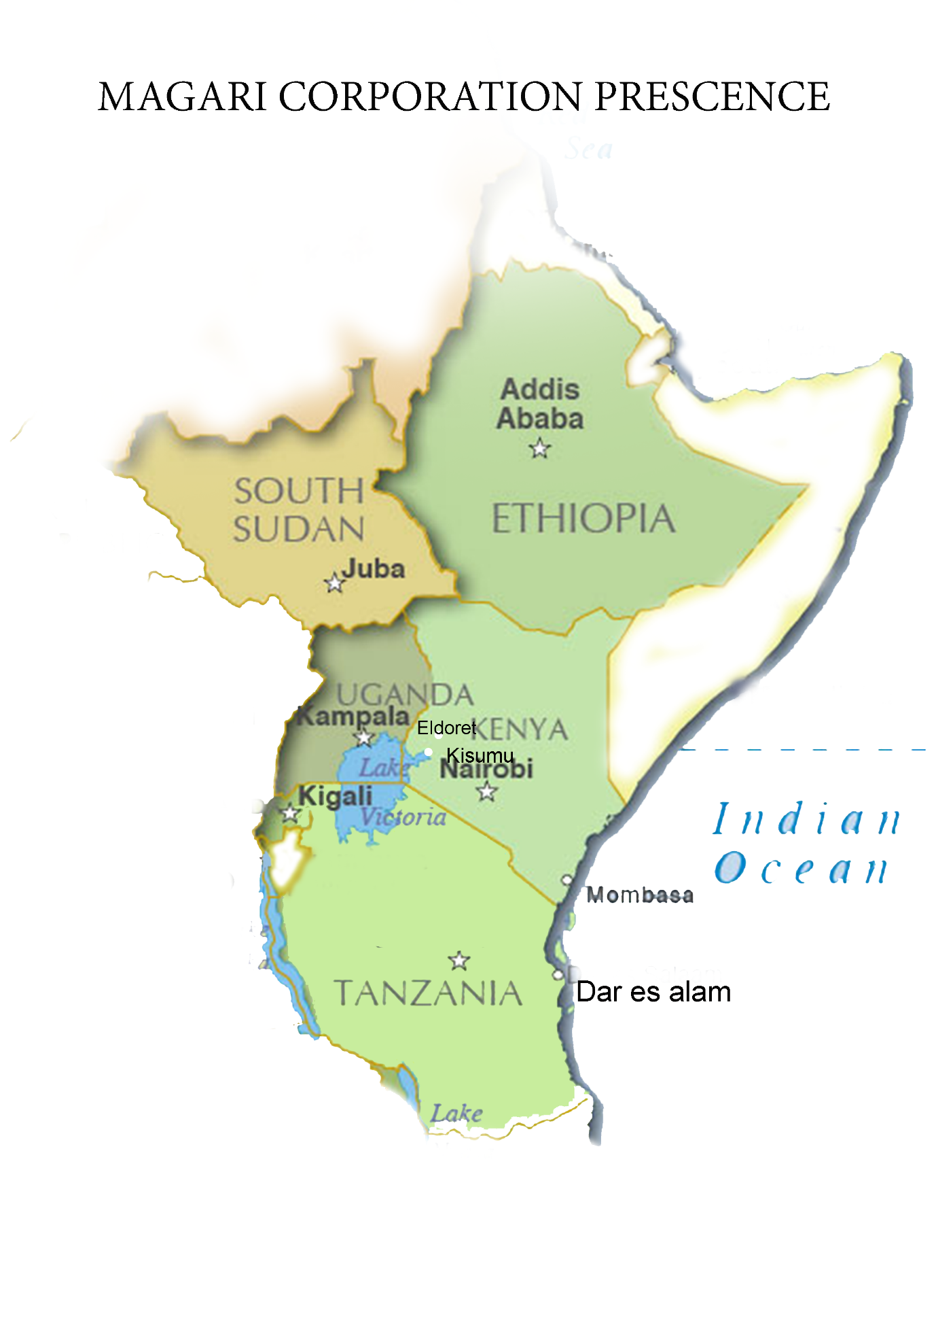

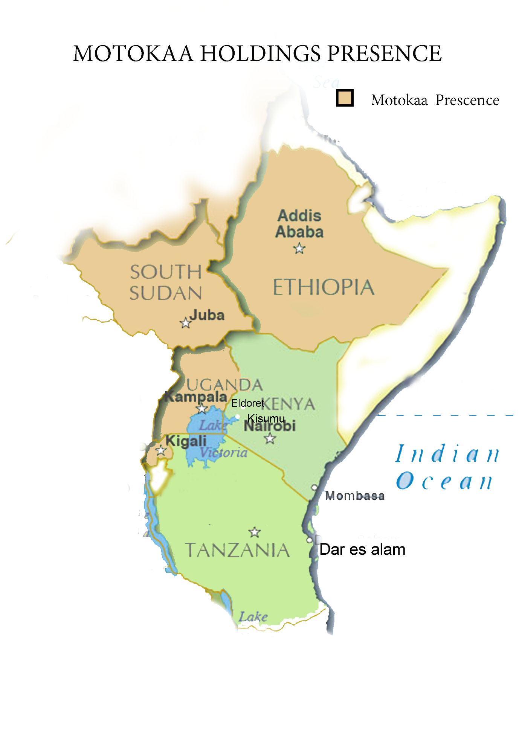

**APPROACHES USED IN SOLVING THE PROBLEM.**

* **Research** on laws and infrastructure in the respective territories.

These laws will help monitor within the system the vehicles being imported and distributed to prevent extra costs that may arise.

**Example**: if the system indicates the maximum age of vehicles since manufacturing that are allowed in a given country, the system will reject older vehicles and thus protect the company from getting on the wrong side of the law.

Results from the research done in the countries is as follows:

* **Kenya**

Vehicles of over 8 years old are not allowed.

Import Duty: 25% of the CIF value of the vehicle.

An importer will have to enlist the services of a clearing agent who will process the import documentation.

The currency exchange is at 1 US Dollar = 101.3475 Kenyan Shillings

* **Rwanda**

Main mode of transport is Road. There are no railways yet and the country is landlocked.

The vehicles should not be more than 5 years from their date of manufacture to the date of import.

The currency exchange is at 1 US Dollar = 806.6500 Rwandan Francs

* **South Sudan.**

There is no age limitation for vehicles imported neither is there mandatory pre-shipment inspection. The cars can be both right and left hand driving.

The currency exchange is at 1 US Dollar = 6.0700 Sudanese pounds

* **Tanzania**

There is no age limitation on used cars but the taxes vary depending on age.

Cars with left hand driving are prohibited.

The currency exchange is at 1 US Dollar = 2189.6500 Tanzanian Shillings

* **Ethiopia**

There is no age limitation on used cars but the taxes vary depend on the engine cylinder capacity.

The currency exchange is at 1 US Dollar = 22.173 ETB

* **Uganda**

There is no age restriction on cars.

The currency exchange is at 1 US Dollar = 3418.8999 Ugandan Shillings..

* **Designing an ERP System** that will be implemented.

The team proposed to use an off-the-shelf ERP system and modify it as per the design to suite the corporation’s required modules and functionalities.

Due to the little time allocated to the project, it would be more efficient to use an off the shelf ERP System. In this case we opted for the Oracle ERP suite due to the following reasons:

* Oracle is known for ‘unbreakable’ security and all the Oracle Apps are covered by the robust role based security system.
* The implementation risk of Oracle ERP is lesser than that of SAP. The ‘2014 Clash of the Titans’ report by Panorama Consulting has indicated that implementation failures occur more in SAP than Oracle, according to customers’ feedback
* Speaking about the implementation cost, it is way less than SAP. On an average, Oracle customers usually need to pay 1.7% of their total annual revenues for implementation.
* Oracle ERP allows customization which is one of its best USPs. Customers can modify certain aspects to suit their specific requirements with the help of an expert or an Oracle consultant company.
* Since more and more organizations are adopting cloud technology, both Oracle and SAP have launched their cloud solutions but according to the general market feedback, Oracle has been more successful to make their customers upgrade the ERP solutions into cloud format.
* Oracle ERP suite adopts fast with the latest legal and technological standards that keep arising from time to time. This is one of the areas where they have got an edge over SAP.
* It has got a great UI which is functional and user-friendly.
* Since it is based on the database technology, it integrates everything inside a single database and so report creation is fast and report sharing is swift.

**INTEGRATED ERP SYSTEM FLOWCHART**

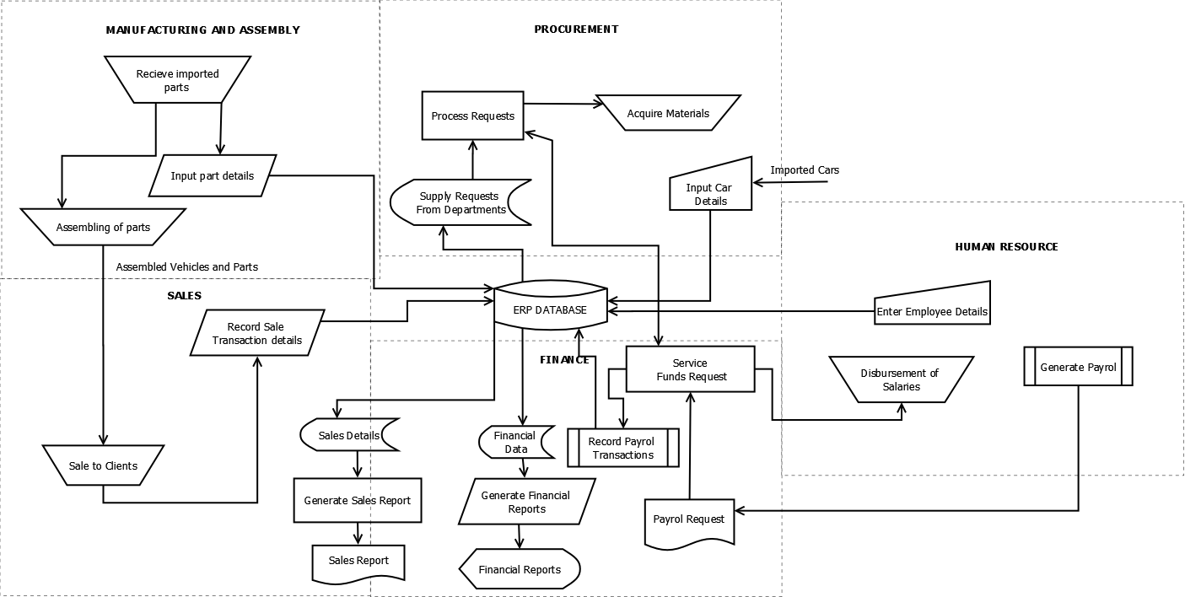

The above System Diagram includes the following modules:

* Manufacturing and Assembly.

Receives imported parts.

Assembles parts.

Distribution of the already assembled vehicles to the sales unit.

* Sales

Gets assembled parts and vehicles from the manufacturing and assembly unit.

Make sales to clients.

Gives an output of the money from the sales made.

* Finance

Gets a report from the sales.

Receives requests for money from the procurement unit.

Releases finances to the procurement unit and human resource.

Provide financial reports and projections.

* Procurement

Orders for imports.

Receives requests from the manufacturing and assembly unit.

Receives cash from finance department.

Acquisition of requested data and resources.

Service requests from other departments and units.

* Human Resource

Receives money from the finance unit.

Disburses the salaries.

Data entry about employees.

Management of employees.

* The project team will work with a cross-functional and cross-cultural team with members from various countries to make this project a success both at headquarters and within the regions. Within the project team, there will be representatives for each country who will work directly with the members of the cross-functional and cross-cultural team.

Board of Management

Project Manager

Cross-Cultural team

Representatives for the countries within project team

Project team

The cross-cultural team will have members from both Motokaa Holdings and Magari Corporation from the various countries where the companies are present. This is to ensure that both companies feel like they are part of the project implementation.

This team will help in change management since they will have been trained from when the project started to the end.

The project team came up with a Gantt chart that had a clear outline of the sequence of activities that would take place in the 12 months allocated to the project.

|  |  |  |  |  |  |  |  |  |  |  |  |  |
| --- | --- | --- | --- | --- | --- | --- | --- | --- | --- | --- | --- | --- |
| **TASK** | **1st Month** | **2nd Month** | **3rd Month** | **4th Month** | **5th Month** | **6th**  **Month** | **7th Month** | **8th Month** | **9th Month** | **10th Month** | **11th Month** | **12th Month** |
| **INITIALIZATION/ CONCEPTUAL**  **Research**  **Feasibility**  **Study** |  | |  |  |  |  |  |  |  |  |  |  |
|  |  |
| **PLANNING** |  |  |  |  |  |  |  |  |  |  |  |  |
| **EXECUTION**  **-Acquisition and integration of the ERP**  **-Data migration** |  |  |  |  |  |  |  |  |  |  |  |  |
| **CONTROL AND MONITORING** |  |  |  |  |  |  |  |  |  |  |  |  |
| **CLOSING**  **2 months training**  **1 month pilot study** |  |  |  |  |  |  |  |  |  |  |  | |
|  |  |

**TEAM ORGANIZATION**

**TEAM MEMBERS**  **REG No** **ROLE.**

King’oo Caroline Katumbi BIT-001-1617/2014 Project Manager

Gikaara Anne Wamahiga SCT221-9817/2015 S.Sudan Rep, Documentation

Lincoln Kiplimo BIT-001-5328/2014 Ethiopia Rep

Gitonga Caroline BIT-001-1614/2014 Rwanda Rep

Thani Ali Said Ali BIT-001-7973/2014 Kenya Rep

Wincasty Kariuki BIT-001-4962/2014 Uganda Rep

Mitchel Ocheing BIT-001-4915/2014 Designer

Orimbo Olak BIT-001-1632/2014 Tanzania Rep

Clinton Ogada BIT-001-3513/2013 Systems Analyst

**KEY CHALLENGES THAT WE FACED IN THE ASSIGNMENT AND HOW WE OVERCAME THEM TO SOLVE THE PROBLEM.**

* Late submission of deliverables by some team members. The team members had to work for more hours in order to cover up for the lost time.
* Some of the team members fell sick. The project manager had to assign the other team members these roles so that the activities occurred as planned.
* Limited resources. These included internet connectivity for research, software resources for design purposes and hardware resources. The team members had to make great sacrifices.
* Different views from the diverse team members. At the beginning, the team members had different approaches to the question and it took a bit of time for the team to agree on one approach.